Introduced by Council Member Corrigan and substituted by the Land Use and Zoning Committee:

ORDINANCE 2009-443-E
AN ORDINANCE AMENDING SECTION 656.399.19 (IDENTIFICATION OF CHARACTER AREAS), SECTION 656.399.23 (OFFICE CHARACTER AREA STANDARDS) AND SECTION 656.399.25 (HISTORIC RESIDENTIAL CHARACTER AREA STANDARDS), SUBPART O (RIVERSIDE/AVONDALE ZONING OVERLAY), PART 3 (SCHEDULE OF DISTRICT REGULATIONS), CHAPTER 656 (ZONING CODE), ORDINANCE CODE, TO MODIFY THE MAP OF THE CHARACTER AREAS TO REVISE THE STOCKTON STREET CORRIDOR AND REVISE THE PARKING REGULATIONS IN THE OFFICE CHARACTER AREA AND HISTORIC RESIDENTIAL CHARACTER AREA; PROVIDING AN EFFECTIVE DATE.

BE IT ORDAINED by the Council of the City of Jacksonville:
Section 1. Figure 1.0 Character Area Map in Section 656.399.19 (Identification of Character Areas) of Subpart O (Riverside/Avondale Zoning Overlay) of Part 3 (Schedule of District Regulations) of Chapter 656 (Zoning Code), Ordinance Code, is hereby stricken and replaced with the Figure 1.0 Character Area Map provided below:

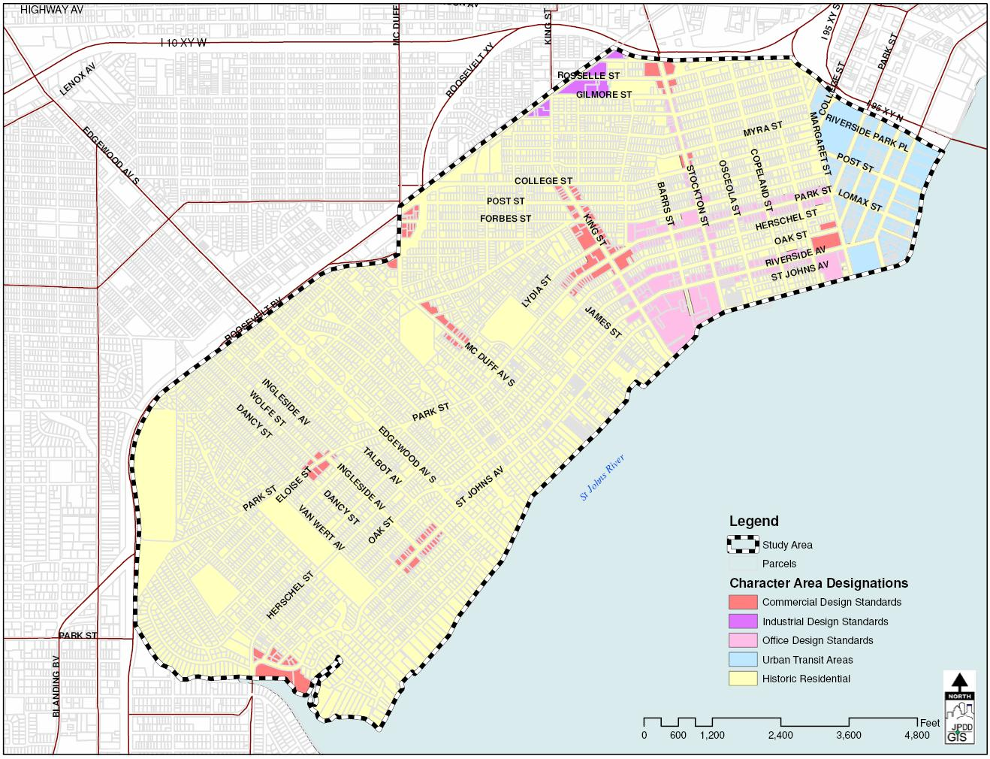
Figure 1. Character Area Map
Section 2. Sections 656.399.23 (Office Character Area Standards) and 656.399.25 (Historic Residential Character Area Standards) Amended. Sections 656.399.23 (Office Character Area Standards) and 656.399.25 (Historic Residential Character Area Standards) of Subpart O (Riverside/Avondale Zoning Overlay) of Part 3 (Schedule of District Regulations) of Chapter 656 (Zoning Code), Ordinance Code, are hereby amended to read as follows:
CHAPTER 656
ZONING CODE
* * *
PART 3
SCHEDULE OF DISTRICT REGULATIONS
* * *
SUBPART O
RIVERSIDE/AVONDALE ZONING OVERLAY
* * *

Sec. 656.399.23. Office Character Area Standards.

(3) Parking Requirements

(a) Conversions to office or commercial uses for a contributing historic structure shall be required to provide a minimum of fifty (50) percent of the required parking regulations in Section 656.604 and Section 656.604(e)(3) for any type of office use, and provided there are no additional parking credits applied under Section 656.607(d) of the Zoning Code. Conversions of contributing structures with a non-residential original use to residential uses may provide 50 percent of the required number of parking spaces set forth in Section 656.604(a). 65% of the required number of spaces in Section 656.604(e)(3) shall be provided for conversions to office uses for any type of office use, or Section 656.604 for commercial uses of non-contributing structures or new construction, provided there are no additional parking credits applied under Section 656.607(d) of the Zoning Code. However contiguous on-street parking may be provided consistent with Section 656.399.23(2)(b)(i-iv) and Table 4.
* * *
Sec. 656.399.25. Historic Residential Character Area Standards.
* * *
(2) Parking Requirements.
(a) There are no additional parking credits applied under Section 656.607(d) of the Zoning Code. Additionally, parking for conversions to office uses or new structures shall be provided on-site and no shared parking agreements will be considered for determining compliance with the parking requirements. All on-site parking for office, single-family and duplex or quadplex multi-family uses shall be stabilized and of a pervious nature, except for the driveway and required ADA accessible spaces. Conversions of contributing structures with a non-residential original use to residential uses may provide 50 percent of the required number of parking spaces set forth in Section 656.604(a).
* * *
Section 3. Effective Date. This Ordinance shall become effective upon signature by the Mayor or upon becoming effective without the Mayor’s signature.

Form Approved:

/s/ Shannon K. Eller_____________
Office of General Counsel
Legislation Prepared By: Dylan T. Reingold
/tmp/in/input.doc

